Digital Alarm Clock

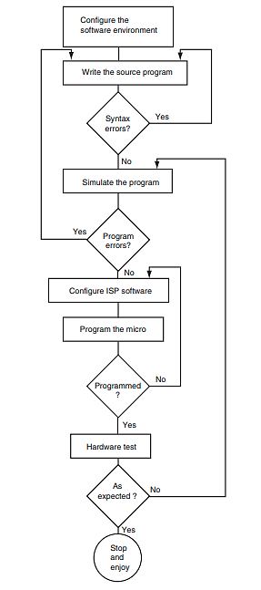

|  |  |  |  |  |  |  |
| --- | --- | --- | --- | --- | --- | --- |
| Date: | 15/12 | 17/12 | 19/12 | 21/12 | 23/12 | 25/12 |
| 4x3 keypad scanning |  |  |  |  |  |  |
| modifying keypad for *, # |  |  |  |  |  |  |
| Declaration of strings |  |  |  |  |  |  |
| Updating the time/adding checks |  |  |  |  |  |  |
| Interfacing with 2x16 LCD |  |  |  |  |  |  |
| Specifying pins and adding buzzer |  |  |  |  |  |  |

|  |  |
| --- | --- |
| Adil |  |
| Mahad |  |

INPUTS AND OUTPUTS OF DEVICES:

Giving Data to LCD

Giving Commands to LCD

Giving signal to LCD when invalid input is given

Giving signal to the buzzer at the alarm time

Input 1: * or # digit

Input 2: Any digit from 0 to 9

KEYPAD

Input 3: Any digit from 0 to 9

Input 6: * or # digit

Input 5: Any digit from 0 to 9

Input 4: Any digit from 0 to 9

Displaying time with AM and PM

Commands using the keypad

Displaying updated time with AM and PM

**LCD** (LM016L)

**BUZZER**

Ringing for 5 seconds

Input at the alarm time

Displaying the inputs at that instant

Displaying “Invalid Input” if an invalid input is given

Data using the keypad